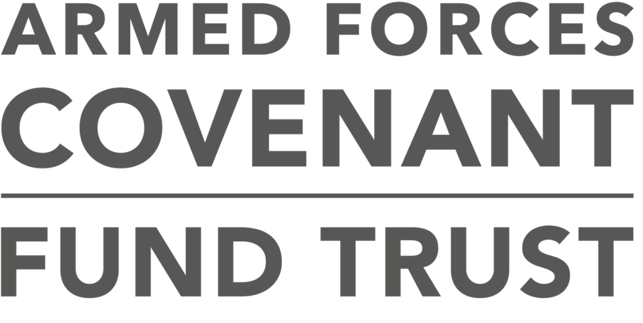

Armed Forces Covenant Fund Trust

Standard terms and conditions –Armed Forces Covenant: Local Grants

This Grant Agreement is important. It sets out the standard legal conditions of our grant offer to you. You accept that these standard terms and conditions are not negotiable.
This is a legal document and you should ensure that you fully understand your responsibilities before accepting a grant from us.
1. Definitions
- “You” and “your” means the organisation receiving a grant from the Armed Forces Covenant Fund Trust subject to these terms and conditions.
- “We”, “us” and “our” means the Armed Forces Covenant Fund Trust and includes our employees and those acting for us.
- The ‘Project’ means the project or activity that we have agreed to support with a grant, as set out in your application form together with any supporting documents and/or as varied by your Offer Letter.
- The ‘Grant Agreement’ includes and incorporates:
- these standard terms and conditions;
- the Offer Letter which sets out any additional conditions; and
- your application to us
2. The Grant
2.1 You acknowledge that you are holding the grant on trust for the beneficiaries of the Project and therefore you must use the grant exclusively for the Project.

2.2 The amount of the grant is set out in the Offer Letter. We are not able to increase the amount of the grant. The amount of the grant may be different to the amount that you applied for.

2.3 You must accept our offer within four weeks of receiving it by signing and returning one copy of the Offer Letter. If you do not return the signed Offer Letter within four weeks our offer will lapse. The Offer Letter must be signed by two people who are authorised to sign on your behalf.

2.4 The Grant Agreement will come into force on the date that we receive the signed Offer Letter from you.

2.5 You must tell us promptly about any changes to information you have given us, including any changes to your bank or building society details and you must make sure that the information we hold about your organisation is always true and up to date.

2.6 You must tell us immediately if any offer of match funding for this project which you told us you would receive is withdrawn or reduced at any time during the Project or if additional funding is offered.

2.7 You must not use the grant to pay for any spending commitments you have made before the date of the Grant Agreement.

2.8 You must hold any unused part of the grant on trust for the beneficiaries of the Project at all times and if you spend less than the whole grant on the Project, you must return the unspent amount to us on demand.

2.9 We will pay the grant by bank transfer (BACS) into a UK-based bank account or building society account in your name, which requires the signatures of at least two authorised people for every withdrawal. You will not use ATM’s or debit cards to make cash withdrawals or payments from this account for any purchases in relation to this Project. You will not pay for items funded by the grant above £100 with cash payments and this will be evidenced in the receipts.

2.10 You will show our grant as a restricted fund in your accounts and acknowledge our grant in your annual report and accounts covering the period of the Project.

3. The Project

3.1 You must start the Project within one month of the date in which you receive the grant.

3.2 You agree to deliver the Project within 12 months of the date of the Grant Agreement.

3.3 If you want to enter into an agreement with any third party with a view to commercial exploitation of the Project or anything relating to it, you must contact us to obtain our prior written consent. Our consent may be subject to conditions, including conditions requiring the repayment of all or part of the grant.

3.4 If you are required by us to enter into a partnership agreement with another organisation or organisations in order to deliver the Project then you will submit the proposed partnership agreement to us for our approval and understand that you cannot start the Project until you have a signed partnership agreement in place. The partnership agreement must ensure that you are named as the accountable body for delivering the Project. You should also ensure that your partner(s) must act at all times in accordance with these terms and conditions of grant, so far as applicable to their role on delivering the Project, and in the event of conflict between the terms of the partnership agreement and these terms and conditions of grant, then these terms and conditions of grant must take precedence.

3.5 You must maintain adequate insurance at all times. This includes employee and public liability insurance. If any assets have been funded by the grant then you will keep them safely and in good repair and condition and will make sure you have adequate insurance cover for all of them. If the asset is damaged, destroyed or stolen, you must tell us in writing and you must repair or replace it as soon as reasonably practical.
3.6 You agree to comply with all laws regulating the way you operate, the work you carry out, the staff you employ or the goods you buy. You will ensure that you have an equal opportunities policy in place at all times, to help you comply with all relevant laws and good practice whilst the Grant Agreement remains in force. You will obtain any planning permission and all approvals, copyright and other consents and licences required by law or by us. This will include, but without limitation, compliance with all employment legislation, equality legislation, health and safety requirements, data security, compliance with the requirements of GDPR and all other relevant legal or regulatory approvals necessary for the Project to be delivered. In particular, but without limitation, you will ensure

that all staff or volunteers involved in the delivery of medical and /or specialist activities or therapies are professionally trained and fully and appropriately qualified and insured.
3.7 If your Project involves work with children or adults at risk (“vulnerable people”), you will take all reasonable steps to ensure their safety. You will obtain the written agreement from the legal carer or guardian before having any direct contact with any vulnerable person. You will have and carry out an appropriate written policy and have a set of procedures in place at all times to safeguard vulnerable people which will include; procedures to
check backgrounds and disclosures of all employees, volunteers, trustees or contractors who will supervise, care for or otherwise have significant direct contact with vulnerable people with the Disclosure and Barring Service.

4. Information, marketing and publicity

4.1 You must follow our branding and publicity guidelines at all times if practical and appropriate. You will acknowledge the Armed Forces Covenant and the Armed Forces Covenant Fund Trust by following the guidelines we will provide. You should feature the required logos on any grant funded building or vehicle and on all information, marketing and publicity materials including digital media relating to the Project. You should also incorporate verbal and written acknowledgment of our support into your communications.

4.2 You hereby give us permission to use, in our sole discretion and as we think fit, any materials produced for or by the Project. You hereby grant us a non-exclusive, worldwide, royalty free perpetual licence to reproduce part or all of your Project or related documents as we may reasonably require for marketing, publicity, research and evaluation and reporting purposes.
5. You agree that
5.1 You will ensure that you are at all times correctly constituted and that you can deliver the Project under the terms of your constitution and if
asked by us you will provide a legal opinion from your solicitors confirming this.

5.2 You must write to us as soon as possible if any legal claims are made or threatened against you and/or which would adversely affect the Project during the period of the grant (including any claims made against members of your governing body or staff).

5.3 You must tell us in writing as soon as possible of any investigation concerning your organisation, trustees, directors, employees or volunteers carried out by the Police, Charity Commission, the Office of the Scottish Charity Regulator, the Charity Commission for Northern Ireland, HM Revenue & Customs or any other regulatory body.

5.4 You understand and accept that we will monitor the progress of the Project and require you to complete all the activities specified in the Offer Letter on time.

5.5 You must send us any information we may reasonably request and records that we reasonably require from time to time in order to monitor your Project and how the grant is being used.

5.6 You will be available for meetings with us, as may be reasonably requested, relating to the Project.

5.7 You will inform us immediately in writing of anything that significantly delays, threatens or makes unlikely the Project’s completion, including any delay or difficulty in fulfilling your obligations to work with others as specified in the Offer Letter.

5.8 If we ask, you will allow us, any person nominated by us or the National Audit Office, access to all records relating to the Project and/or subsequent profit made by the Project upon demand, including (but not limited to) accounts and any other financial records, VAT and any other tax records. If any part of the grant is to buy an asset or a series of assets items which have an economic life of five years or more, regardless of cost you will keep all receipts and invoices for us to look at. We can ask for access to these records for up to seven years after the Project has finished.

5.9 You will provide us with a full report on the Project within three months of completing it, using our end of grant report form which we will send to you. We understand that the grant is finished only after you have completed this report to our satisfaction and we have received to our

satisfaction, the evidence of expenditure we have requested for the period of the Grant Agreement.

6. General conditions

6.1 If you fail to meet any term and/or condition of the Grant Agreement and we do not enforce one or more of our rights straight away, this does not mean that we will not do so in the future. We will give up our right to enforce this Grant Agreement only if we tell you in writing.

6.2 We will not be held responsible for any action you take, any action you fail to take, or for your debts or liabilities. You are fully responsible for every part of the delivery and content of the Project or for your organisation and the decisions about them. We will not be responsible to anyone else who may take, or threaten to take, proceedings against you.

6.3 You accept that we may share information about your grant with any parties of our choice as well as with members of the public under
the Freedom of Information Act 2000. Details of the grant may be broadcast on television, on our website, in newspapers and through other media.

6.4 You acknowledge that the grant comes from public funds and you will not use the grant in a way that constitutes unapprovable State aid.
In the event that it is deemed to be unapprovable State aid, then you will repay the entire grant immediately.

6.5 You may not transfer any part of the grant or this Grant Agreement or any rights under it to another organisation or individual, unless you have entered into an agreement, authorised by us in accordance with clause 3.4.

6.6 We may reject any future application from you to other programmes we run if you do not comply with these terms and conditions or we judge that you did not handle the grant adequately or if you failed to complete any requests for information we made to you.
7. VAT
7.1 You acknowledge that the grant is not consideration for any taxable supply for VAT purposes. You acknowledge that our obligation does not

extend to paying you any amounts in respect of VAT in addition to the grant.

7.2 If you are registered for VAT, or subsequently become liable to register for VAT, you must keep proper and up to date records and you must make those records available to us and give us copies when requested.

7.3 If we have agreed to fund any or all of the VAT costs associated with your Project and you subsequently recover any VAT, you must pay us back immediately any of the VAT that has been paid for with the grant.
8. Conditions relating to assets or services purchased with the grant
8.1 If any part of the grant is used to buy any assets, such as buildings, vehicles, computer equipment or intellectual property or a series of related assets or services or a series of services costing more than £10,000, you will put out the order to competitive tender. If there are good reasons why you cannot tender, you will obtain our written agreement beforehand. You will comply with all anti-bribery and anti-corruption legislation.

8.2 You will not sell, give away or borrow against any grant funded assets during the period of their economic life without first receiving your written consent. As the grant comes from public funds, you understand and accept that if we do provide written consent we may require that the sale is at full market value and/or subject to conditions requiring you to repay all or part of the money you receive.
9. Breach of these terms and conditions, and suspending or repaying the grant
9.1 If you fail to meet any of these terms and conditions, we may, in our absolute discretion:
- require you to pay back all or part of the grant (regardless of how much you may have already spent if you have not spent it in accordance with these terms and conditions); and/or
- end this Grant Agreement immediately.

9.2 We may recover the grant (in full or such part which has not been properly spent and/or accounted for) in our absolute discretion, if any of the following events occurs:
    - your organisation closes down (unless it joins with, or is replaced by, another organisation that can carry out the Project and we have provided our prior written permission);
    - you make any changes to the Project with first getting our written permission;
    - you use the grant for anything other than the Project;
    - you do not follow our reasonable instructions;
    - you do not carry out the Project with reasonable care, thoroughness and competence;
    - you do not complete the Project on time;
    - you have supplied us with any information that is wrong or misleading, either by mistake or because you were trying to mislead us;
    - you act illegally or negligently at any time, and we believe it has significantly affected the Project, or is likely to harm our or your reputation;
    - you use the grant or any part of it for any activity is intended to influence or attempt to influence Parliament, Government or political parties, or attempts to influence the awarding or renewal of contracts and grants, or attempts to influence legislative or regulatory action; and/or
    - without first getting our approval in writing, you sell or in some other way transfer the grant, your organisation or the Project to someone else.
9.3 If you breach any of the terms of this Grant Agreement, we can choose to treat that as if you had breached the terms of any other grant agreements we have with you. This will allow us to take the same actions under those agreements that we may take under this Grant Agreement.

10. Termination of the Grant Agreement
10.1 These terms and conditions and the Grant Agreement remain in force for whichever of these is the longest time:
- for one year following the payment of the last instalment of the grant;
- as long as any part of the grant remains unspent;
- the expiry of the maximum period required under the Grant Agreement for asset monitoring;
- as long as you do not carry out any of the terms and conditions of the Grant Agreement or any breach of them continues (this includes any outstanding reporting on grant expenditure or Project delivery).

11. Additional conditions
11.1 We have the right to impose additional terms and conditions on the grant if:

You are in breach of the Grant Agreement;

We withdraw any part of the funding for the Project;

We judge that members of your governing body, volunteers or staff or any person or organisation closely involved in carrying out the Project act in a way that may have a detrimental effect on the Project or the reputation of the Armed Forces Covenant or the reputation of the Armed Forces Covenant Fund Trust;

We have reasonable grounds to believe that it is necessary to protect public money; and/or

We believe such conditions are necessary or desirable to make sure that the Project is delivered on time and/or as set out in the application form or following any agreed changes.

