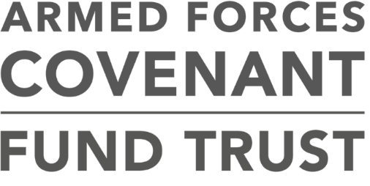

**Tackling Serious Stress in Veterans, Families and Carers**

**Programme guidance**



**This document describes the programme aims and provides guidance for applicants applying for the Tackling Serious Stress in Veterans, Carers and Families Programme.**

**Summary**

This programme will make a small number of grants to single lead organisations who will work with delivery organisations. A single lead organisation will need to be an organisation with the skills and experience to manage a large grant.

The programme will make around five grants in the region of £300,000-£700,000. It is anticipated that the programme will fund one portfolio each in Scotland, Wales and Northern Ireland, and two portfolios in England.

All funded portfolios will participate in an overarching research project which will explore whether the support that the portfolios of projects are delivering is better than existing statutory services on offer.

**Contents**

**Veterans with Serious Stress; their partners, families and carers** 3

**Programme aims** 4

**The key criteria** 5

**The application process** 7

**Who can apply?** 8

**Who cannot apply?** 10

**Application Process** 10

**What expenditure can you apply for?** 11

**How long should portfolios last?** 12

**The evaluation and support provider** 12

**After you submit your application** 12

**Assessment and decision making** 12

**Accepting our offer** 13

**Complaints** 13

**Introduction**

The Covenant Fund makes grants in support of the Armed Forces Covenant. There are four overall themes that the Covenant Fund must take into account now and in future years when allocating the annual funding.

1. Non-core healthcare services for veterans;

2. Removing barriers to family life;

3. Extra support both in and after service for those that need help; and

4. Measures to integrate military and civilian communities and allow the Armed Forces community to participate as citizens

The Covenant Fund is run by the Armed Forces Covenant Fund Trust. It was previously run from within the MOD. This programme supports the third theme of providing extra support after service for those that need help.

# **Veterans with Serious Stress; their partners, families and carers**

This programme will support organisations helping veterans with severe mental health needs who do not meet the usual criteria for hospitalisation and inpatient treatment; and are encountering severe or substantial stress.

Veterans with lower level needs can receive support from General Practitioners, general mental health (e.g. IAPT) services and bespoke community and voluntary sector services. It is however likely that there are some veterans who have complex and challenging needs that are too complex for community-based services, but not severe enough to meet the inpatient criteria for crisis care. These needs could include those with addiction, complex PSTD type disorders, and possibly with chronic poor mental health that has a significant impact on the veteran being able to carry out day to day activities

The consultation for this programme showed high levels of support for provision for families and carers under this programme

*“It is vital that we fully support the role of Carers and families”*

*“Carers and families are the backbone to delivering this project effectively.”*

Respondents to the Tacking Serious Stress Consultation

The intention of this programme is to make a small number of large grants that will enable charities and health professionals to work together in a portfolio to develop and try new ideas that they have to support veterans and their carers and families and where there is good evidence to suggest that this portfolio of work might produce outcomes that are better than current sources of support on offer.

Families and carers are an important priority under this programme. Supporting families and carers of veterans with severe mental health needs will enable those in a caring role to continue to offer substantial and critical support to the veteran with needs. The Armed Forces Covenant Fund Trust ran a consultation to help shape this programme. The [consultation report](http://www.covenantfund.org.uk/wp-content/uploads/2018/09/Consultation-report.pdf) is available. The concept of supporting carers and peers who are living under daily stress themselves and who may need help themselves received a high level of support.

The responders to the consultation have helped shape our programme design around the following key elements

# **Programme aims**

This £4 million programme will provide funding towards supporting innovative and new ways of working to reduce serious stress in veterans, their carers and families by providing additional resources to create the space to try unique ways of working that are on top of existing services. This programme aims to fill gaps in statutory provision, making a genuine and lasting difference to those in significant need, while not overlapping with any of the existing mental health services or other statutory support. This programme will seek to drive longer term sustainability for projects within portfolios that are proven to offer value to veterans, their families or carers; through having a unified approach to impact and evaluation.

The aims of this programme are

* **to offer innovative support to seriously unwell veterans and their families and carers**
* **by working with the research and support provider, to assess the impact that the projects within each portfolio has had on seriously unwell veterans and their families and carers; and**
* **to explore how effectively this work could be replicated more widely**

# **The key criteria**

There is a single stage application process for this programme..

The main assessment criteria are:

* how well a portfolio of projects addresses the aims
* how well your portfolio of projects fits within the interventions that have been identified
* the quality and benefits of partnership working and collaboration
* how well the programme of projects is likely to be delivered
* to what extent the plans represents value for money
* to what extent the projects within your portfolio are safe and effective; and are not currently available
* to what extent we can have confidence that the work delivered by your portfolio will have lasting impact, delivering changes that last beyond the funding period
* how successfully you have worked with veterans and their families and carers to develop your portfolio

Please note also that:

* + we cannot fund a service that is or should be provided by statute
  + portfolios must not generate a surplus
  + all the projects within a portfolio should be completed within two years of receipt of funding.
  + we will only fund portfolios that support veterans and their families and carers where it may be that the serious level of mental ill health that does not qualify for hospital admission, but is having a severe or substantial impact on their quality of life

**We will make grants to single lead applicants who work with delivery projects. We explain more about this below**

|  |  |
| --- | --- |
| **Assessment criteria** | **What we are looking for** |
| **How well your overall portfolio addresses the aims** | Your portfolio idea should be innovative. We will consider applications to further develop an existing idea. You must be able to explain why you think your portfolio will offer better support than is currently available. You must be able to commit to working with the evaluation provider. You should be prepared for the findings of the projects within your portfolio to be disseminated widely. The consultation showed strong support for projects that support families and carers. We anticipate that most of the portfolios we fund will have a component that supports families or carers. You can apply for a portfolio that does not have a carer element, but you will need to tell us why it is not appropriate to support carers through your idea. |
| **How well your overall portfolio fits within the interventions that have been identified** | The identified interventions are   * New ways of providing respite care locally that supports the veteran to remain connected to their community while supporting their carer * Pathways of care for addiction treatment * Trialling the Recovery (“transition”) college model * Supporting carers and peers where they are experiencing severe stress or other illness and/or to maintain good mental health and prevent crises * Enabling more cost effective and reliable recovery from addiction and dependency * Supporting planned short term residential services that enhance resilience, prevent relapse/crisis, and enable sustainable long term purposeful living   Within the consultation responses, a strong level of priority was given to projects that support families or carers. As a result; your portfolio should support families or carers as well as veterans unless there is a good reason why it would be inappropriate to do so.  There were low levels of support for addiction support. We will still accept proposals for addiction related projects within portfolios, but you will need to be very clear on the need for this project and why it is additional. Your portfolio can address more than one intervention theme. Within the consultation; a need was identified for outreach support. Your portfolio can include outreach and engagement type activities with a veteran and carers as a supplementary, rather than a core activity |
| **Partnership working and collaboration** | We will only support portfolios that contain a number of delivery organisations. At least one voluntary sector organisation must be included as a delivery organisation. We are particularly keen to encourage cross sector partnerships, bringing in specialist resources and expertise |
| **How well the portfolio is likely to be delivered** | Your application should be able to show relevant skills and expertise for the work that you are delivering. The governance including clinical governance structures for delivering the portfolio should be clear. You should be able to identify clear milestones for your portfolio. Your portfolio should include the principles of  • Supporting recovery  • Inclusion of carers and peer support  • Service user participation as may be appropriate |
| **To what extent the plans represents value for money** | We will consider the costs of running your portfolio and the costs that your delivery partners will need to deliver their projects. We are aware that the portfolios might ultimately support a limited number of veterans and carers as their needs are complex. In these cases; we would expect to see a clear rational behind why the needs of these veterans and carers are complex; and why you believe that your approach can offer good value for money – perhaps in comparison with alternative types or duration of care. |
| **To what extent the projects within your portfolio are safe and effective; and are not currently available** | The support providers under this programme will assess the clinical appropriateness of your proposal. We will consider evidence regarding whether the intervention that you are seeking funding for is currently available under the NHS. We will only fund projects in your portfolio which are additional to statutory services. |
| **To what extent we can have confidence that the totality of the work within your portfolio will have lasting impact, delivering changes that last beyond the funding period** | Your idea, if shown to have a positive effect that delivers good value for money through the evaluation, should be replicable by others. You should also consider how your delivery partners will be able to sustain the work that they are carrying out. We will also expect to see appropriate exit plans for the veterans and carers reached through your portfolio so that if a continuing source of funding cannot be found; they are not left unsupported. |
| **How you have worked with veterans and their carers to develop your portfolio** | We expect to see you and your delivery partners use the principles of co-design with veterans, their families and carers where possible. We accept that the beneficiaries of your portfolio may have complex needs; and do not require a full co designed proposal in every application. We will look at how veterans, families and carers have been involved in the development of the idea, and how they will have an ongoing voice through the delivery of the portfolio. |

# **The application process**

.The application process is competitive; and we do not expect to be able to make an award to all of the portfolios that apply.

You can apply for a grant for a programme of work to last up to 2 years (starting from March 2019).

Value for money is a key criterion; and larger projects should have better coverage or offer a higher level of support.

Within the application form; you will be asked about the numbers of veterans and their families and carers that you intend your portfolio to reach. We ask this to gain a better understanding of your portfolio. We would be more likely to support a portfolio that shows that it will offer realistic and meaningful support to an achievable number of veterans and their families and carers and that you have considered the location of beneficiaries and the nature of existing provision within your geographical area.

The grants process is competitive; and you should be aware that you may not be offered a grant, or may be offered a grant for a lower sum of money than you have requested.

Your application will need to be submitted by 31st December 2018.

You will find out about the outcome of your application before the end of February 2019

# **Who can apply?**

We will accept applications from a single lead organisation that must be a registered charity or a statutory organisation and who will be responsible for the grant but will work with other organisations to deliver the activities within the portfolio. A lead organisation may deliver one of the projects within the portfolio in addition to managing the portfolio.

We will only accept applications that include a charity or CIC in the delivery plans. We welcome cross sector partnerships, and your application needs to include delivery organisations. We should be able to see how all projects are connected into the main portfolio to achieve good overall likely outcomes for very unwell veterans and their carers and families. You can also include optional advisory organisations to provide support to your portfolio.

|  |  |
| --- | --- |
|  | **Roles and Responsibilities** |
| **Single Lead Organisation** | This organisation will   * Put together a group of projects to be delivered, in the main, by delivery organisations although it could also deliver a project itself * Determine its approach to data collection, data management and data quality following discussions with the University of Chester * Determine their approach to evaluation * Plan their approach to the management of their delivery organisations and advisory organisations * Apply for the grant before 31 December 2018 * If awarded a grant, be the sole accountable organisation for the grant and the delivery of the agreed portfolio on time and on budget * Be responsible for providing all data and other information regarding the grant * Be responsible for the successful delivery of all portfolio projects * Work closely at all times with its delivery and advisory organisations, the University of Chester and the Trust   A single lead organisation will   * Be an established organisation (statutory or charitable) with experience in delivering complex projects to people who are very unwell * Have a track record of successfully delivering complex projects * Have a track record in working with research organisations * Have established mechanisms for governance of complex projects supporting vulnerable adults |
| **Organisation within a portfolio** | This organisation can be either a **Delivery organisation** or an **Advisory organisation**; or if appropriate, it can fill both these roles  **A delivery organisation will**   * Be in contact with a potential lead organisation * Assist the lead organisation in the application stage by providing project details * If a grant is awarded to the Lead Organisation, be responsible for the delivery of the funded project * Receive their funding to deliver their part of the portfolio from the Lead Organisation * Provide all data and other information on the project to the Lead Organisation * Deliver standalone work - but it should be clear in the overall portfolio how all of the separate projects being delivered by the portfolio connect into a coherent whole that provides seamless support for beneficiaries   **An advisory organisation (optional) will**   * Provide advice or guidance to the Lead organisation on the governance; the delivery of the portfolio or the needs and perspectives of beneficiaries * May sit within the wider portfolio governance framework * Have credibility and the professional skills to be offering advice within their subject of expertise |
| **Beneficiaries** | Beneficiaries on this programme are   * Veterans who are  1. experiencing a severe level of mental ill health which is not critical enough to require hospitalisation; and 2. Where current NHS provided sources of support are not meeting their needs  * Carers of the veterans described above * Close family members of the veterans described above who do not self-identify as carers but are experiencing, or are at risk of experiencing, negative impacts to their own wellbeing.   Projects within portfolios must be supporting at least one of the above groups. The needs of families and carers are of particular, but not exclusive, interest to us |

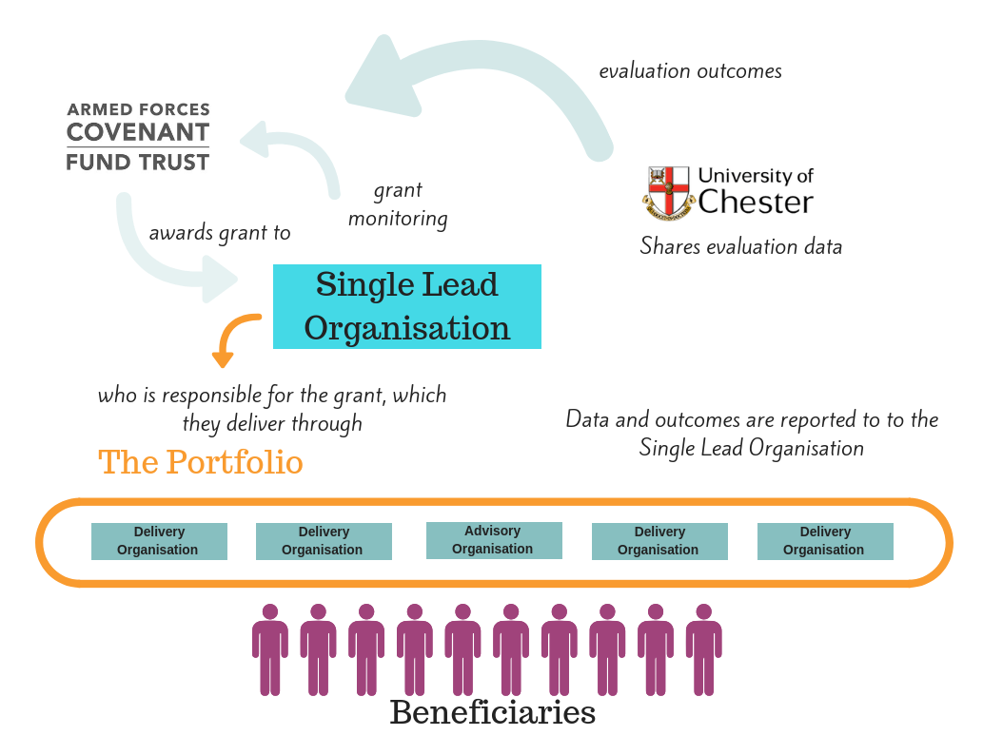

# **Who cannot apply?**

* Individuals
* Organisations delivering a single strand of activity that would fit within a wider portfolio
* Organisations who are not registered with the Charity Commission, the Charity Commission for Northern Ireland or the Office of the Scottish Charity Regulator or registered by the Office of the Regulator of Community Interest Companies

# **Application Process**

There is a one stage application process for this priority. Applications must be submitted online.

If you have not applied for a grant from us since April 2018 you will need to register for our new system. Links will be available on our website

On our new system, you can save a draft application form to complete later; or send a draft copy to colleagues. You can also access copies of the application that you have submitted at any time. When you submit your application, you will receive an email confirmation. If you do not receive this; then you have not applied.

You will need to answer all the questions on the application form. In addition you will need to submit a high-level delivery plan.

Your high level delivery plan should be

* Up to 18 pages long
* Show us your referral and treatment pathways
* Show us your governance and clinical governance structures
* Use diagrams to show us your pathways and structures are particularly welcome
* You can also use your high level delivery plan to tell us about anything important to your portfolio that you have not been able to tell us about in your application form

Your high level delivery plan will need to be included as an attachment to your online application form. It will need to be included in a Word or PDF format. The form will have additional information on how to upload this file.

You do not need to produce a detailed delivery or business plan in order to apply. You do not need to provide detailed budget plans at application stage, but we expect you to be able to answer questions about the budget if we need to contact you during our assessment.

We would strongly advise you to work with others when developing your application. We are unlikely to fund more than five portfolios in total. We may, at our discretion, offer you a grant for less than you have applied for.

We will not be able to increase the size of your grant if awarded.

# **What expenditure can you apply for?**

We anticipate that grants in the region of £300,000 to £700,000 will be awarded. We can pay for most of the revenue costs that you’ll need to administer and deliver your portfolio including the data collection. As we are funding an overarching evaluation of the whole programme that all successful portfolios will be working with, we will not generally pay for additional evaluation costs on top of these. You can talk with the evaluation provider during the application period to help you to understand the time commitment involved in the evaluation work for your portfolio and budget for support staff time accordingly. We will contribute towards your reasonable management costs and also the management costs for each of your delivery partners.

There are a number of things **we can’t pay for** either because they are not relevant to this programme or, not in the spirit of the Covenant Fund, or because of relevant legislation or tax rules. These include:

* Capital schemes such as building a veterans and carers centre
* Topping up existing grants and aid from another Government Department
* Where money only benefits one person
* Repeat or regular projects that require a source of uncommitted funding
* Investments
* Organisational fundraising activities
* Endowments (to provide a source of income)
* Projects, activities or services that the state has a legal obligation to provide
* Retrospective funding for projects that have already taken place
* Excessive contingency costs; management or professional fees

Projects within portfolios that provide standard IAPT (Improving Access to Psychological Therapies), EMDR (Eye movement desensitization and reprocessing), Trauma focused psychotherapies, or Crisis services will not be eligible for funding, but portfolio projects can refer project beneficiaries to any local, appropriate source of support.

The programme will not offer any capital funding, and bids should not duplicate existing pilots or provision.

This is not an exhaustive list as we feel it is more useful to focus on what you are you are trying to achieve and how you are going about this than to issue long lists of eligible and ineligible costs.

If your portfolio strongly addresses the aims of this programme, the spirit of the Covenant Fund and the criteria set out in this guidance, your costs should be eligible.

# **How long should portfolios last?**

We expect to fund portfolios where the projects are delivering work that last for at least one year and up to two years. It is unlikely that sufficient impact will be achieved in any shorter period.

# **The evaluation and support provider**

Please read our separate evaluation guidance document; available on our website.

**When to apply**

June 2018 Programme consultation

14 September 2018 Information event

1st October 2018 Application Guidance and Questions released

31st December 2018 Deadline for applications

February 2019 Decisions are made on awards

If you send your application to us after the final deadline we will not be able to accept it.

# **After you submit your application**

We will acknowledge receipt of your application. We will check your application to ensure that you have provided all the information we have requested. If your application is incomplete or ineligible, we will not be able to process it any further and it will not be considered for funding

# **Assessment and decision making**

We will review the information you provide in your application and will then send your application to our advisors and other key stakeholders.

Portfolios will undergo assessment against key criteria and have to meet high quality standards in order to be successful.

We may contact you during assessment to clarify aspects of your application or ask for additional information. Whether we contact your or not should not be seen as an indicator of your likely success or otherwise.

Final decisions on which portfolios to fund will be made by the Armed Forces Covenant Fund Trustees who will review all applications together using balancing criteria in addition to the key criteria. The balancing criteria include the relative strength and value for money of the portfolio and the location of its proposed delivery when viewed as part of a national profile of provision..

If we do not offer you a grant, we will tell you the reason why in a feedback letter.

# **Accepting our offer**

If we plan to fund your project you’ll need to accept our grant offer and the terms and conditions within **4 weeks** of receiving the offer letter. A member of our team and a researcher from the University of Chester will arrange to visit successful lead applicants in the week commencing 04 March 2019 to discuss milestones and data collection. After that meeting and when you have accepted the offer we will agree detailed milestone and budget profiles with you. Payments will be staged according to the type of expenditure and the project milestones and will be dependent on acceptable reports on the progress of your work

**Timetable**

|  |  |
| --- | --- |
| Open for applications | 1st October 2018 |
|  | |
|  | |
| Final closing date for applications | 31st December 2018 |
|  | |
| Final funding decisions communicated by | End of February 2019 |

|  |  |
| --- | --- |
| Offers to be accepted by | No later than 31st March 2019 |

# **Complaints**

If you are not happy with the way we dealt with your application, please contact us and we will discuss this with you.

Please note that you can only complain if you believe we have not followed our published guidance when dealing with your application. You cannot appeal against the decision.

***About us***

**The Covenant Fund was previously administered by an in-house MOD team and the funding has moved to the new independent trust as from 1 April 2018. The Armed Forces Covenant Fund Trust manages the grant programmes funded by the Covenant Fund. You can find out more about our work at** [**www.covenantfund.org.uk**](http://www.covenantfund.org.uk)**.**

**The Covenant Fund is an annual grant of £10 million from LIBOR funds which is paid to the Armed Forces Covenant Fund Trust to fund grant programmes that support the armed forces community.**

**There are four overall themes that the Covenant Fund must take into account now and in future years when making decisions.**

* **Non-core healthcare services for veterans;**
* **Removing barriers to family life;**
* **Extra support both in and after service for those that need help; and**
* **Measures to integrate military and civilian communities and allow the Armed Forces community to participate as citizens**

***About the Armed Forces Covenant***

**The Armed Forces Covenant is a promise from the nation that those who serve or have served, and their families, are treated fairly.**

**You can find out more at** [**https://www.armedforcescovenant.gov.uk/**](https://www.armedforcescovenant.gov.uk/)



**Contact details**

[**www.covenantfund.org.uk**](http://www.covenantfund.org.uk)

[**enquiries@covenantfund.org.uk**](mailto:enquiries@covenantfund.org.uk)