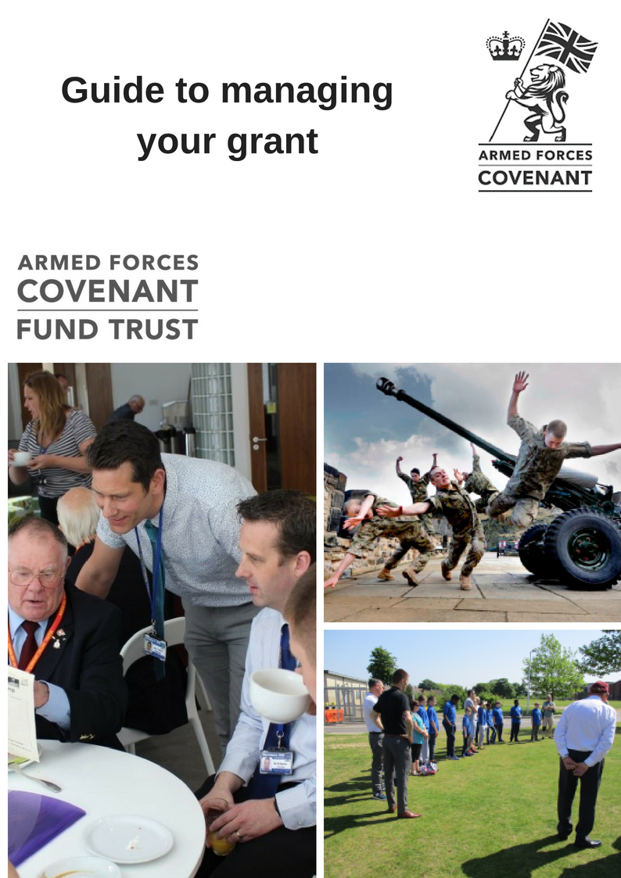

**Congratulations…**

….on being awarded a grant from the Armed Forces Covenant Fund Trust.

**The Armed Forces Covenant**  
*"To those who proudly protect our nation, who do so with honour, courage, and commitment, the Armed Forces Covenant is the nation’s commitment to you.  
It is a pledge that together we acknowledge and understand that those who serve or who have served in the armed forces, and their families, should be treated with fairness and respect in the communities, economy and society they serve with their lives."*

The Armed Forces Covenant is a promise from the nation that those who serve or have served, and their families, are not disadvantaged. The Armed Forces Covenant is also a promise of mutual support between the civilian and armed forces communities.

We wish you success with your funded project, and look forward to hearing about your progress - both in the formal reporting we ask for as part of our terms and conditions, and from your press cuttings, announcements and pictures, which we are happy to receive by email at any time.

The Armed Forces Covenant Fund Trust can only achieve its objectives through the programmes and projects that we support – that is, through you, the organisations to which we award grants.

So, we have put together this guide which we hope will help you understand our expectations as well as give some guidance on promoting your work to add value to the grant you have received.

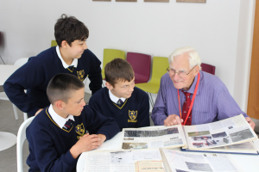

We want to continue to improve the way in which we manage our grant making and how we communicate with those who apply for and receive grants. If you have any suggestions on how we might do this, or comments on this guide, please do let us know using the email address enquiries@covenantfund.org.uk Please also do also contact us on this email address if you have any questions regarding your grant/project.

**Section 1 - Getting started**

**If you have been offered a grant you will have received from us the following documents:**

* An Offer Letter
* Terms and Conditions of Grant
* A payment request form

**What we want back from you: Local Grants (£20,000 and under)**

**Within four weeks of receiving your offer:**

* A hand signed Offer Letter – returned by post
* A completing form requesting payment of your grant, using the above form, ensuring it is completed fully with the requested evidence of your bank details
* A draft copy of any Partnership Agreements you are going in place with Delivery or Project Partners. This should be sent by email to enquiries@covenantfund.org.uk

***\*Please note: Your offer may lapse if we do not receive this information within the four weeks. We will be unable to make any payments until all of the above information has been received correctly.***

**What we want back from you: Large Grants**

**Within four weeks of receiving your offer:**

* A hand signed Offer Letter – returned by post
* A payment request for the first instalment of your grant, using the above form, ensuring it is completed fully with the requested evidence of your bank details
* A draftcopy of any Partnership Agreements you are going in place with Delivery or Project Partners. This should be sent by email toto enquiries@Covenantfund.org.uk

**Within two months of receiving your offer (large grants only)**

* Complete and agreed milestone and payment schedule spread sheets. This must be in *whole pounds* and must take into account the first invoice your will have already submitted.

***\*Please note: Your offer may lapse if we do not receive this information within the time limits. We will be unable to make any payments until all of the above information has been received correctly. More information on payments and monitoring can be found further on in this document.***

**Your Offer Letter**

This represents our formal agreement with you and you need to check it includes all the correct details for your organisation, the amount of grant awarded and the purpose of the grant.

You will need to print out a hard copy and once you have read all the other documents, this should be signed by two suitably authorised people in your organisation. One of them must be the most senior staff member (the chief executive) or the chair of your board of trustees.

We advise that you get at least 2 copies signed, just in case it goes missing in the post and you need to re send it, this will save time.

You need to keep one hard copy for your own record purposes.

You must also advise your board that you have received a grant from the Armed Forces Covenant Fund Trust and ensure that you report to your board on the progress of your project.

Additionally, we will also require details of the main point of contact for your project. This person will normally be the only person we will look to contact regarding your grant and your project, so please ensure you keep us updated with any changes to these details as your project progresses. Please ensure you post the Offer Letter back to us within 4 weeks of receiving your offer pack, as failure to do so may result in your grant offer lapsing.

**Terms and Conditions of Grant**

Please do read these carefully – they describe the formal relationship between the Armed Forces Covenant Fund Trust and grant holders. They are standard and not negotiable on a case by case basis.

**Monitoring**

If you have received a grant under our ***Armed Forces Covenant- Local Grants*** priority (grants up to £20,000 for Community Integration or Delivery of Local Services) you will be expected to complete a form online on completion of your project and we will send you the link to the online form around 9 months after your offer letter. In order to prepare for this you can find a list of the questions you will be asked on [our website](http://www.covenantfund.org.uk/wp-content/uploads/2018/06/End-of-Grant-Monitoring-Form-Questions-June-18.pdf)

Please note that we may make minor changes to the wording or the order of the questions depending on feedback from previous grant holders

For **all other grants** (usually those larger than £20,000) we will expect more regular reports. These will be either quarterly or six monthly depending on the Priority under which you are being funded. Your Offer Letter will explain how frequently these are needed and how to they relate to the schedule of payments. More information on large grant monitoring and payments is explained below.

**Milestone/Payment Schedules and Progress Reporting (for Large Grants only)**

**Partnership Agreements**

**If you are going to work in partnership with another organisation to deliver the Project, and you need to enter into a Partnership Agreement with them in accordance with our terms and conditions, please can you send us the proposed draft agreement within four weeks of receiving your offer letter for our approval.**

**See Section 2 for more explanation of what we will do with these.**

**Grants that are paid in instalments require completion of the Milestone and Payment Schedules that will be sent in your offer pack. This spreadsheet has 4 tabs for the following:**

* **Project Milestones – a break down of your projects delivery and timescales**
* **Budget – Items of expenditure per year**
* **Payment Profile – a forecast of each payment instalment**
* **Progress Report –What you have spent to date in comparison to what you have budgeted for with a description of any variations.**

**We will require these spreadsheets completed before we can issue any payments, and will talk through these with you in detail before you submit them for the first time.**

**These are living documents and should be updated regularly in order to keep a track of any changes made to your project as you go along. This will ensure we are able to easily check spend/progress at any time and when it comes to your reporting time, if these documents are fully complete we can then release funds with minimal delay.**

**Press cuttings/media coverage/photos**

We would like to receive press cuttings (do scan them and email as attachments, or send us the web links), information about media coverage and photos relating to your announcement of getting a grant and as your project progresses. See more information in **Section 5** below about what we will use them for.

**Acknowledging the Covenant Fund**

This guide will give you some ideas about how we would like you to do this, but please remember that acknowledging our funding in any printed documents, websites or on social media is a fundamental term and condition of our funding and we expect to see the logo used where possible.

**Section 2 – What we will do**

**Provide advice on draft Partnership Agreements**

If you need to enter into a Partnership Agreement we will let you know.

If you need a partnership Agreement, you will need to send us a draft version. We will send you comments back on this – either to confirm that they comply with our requirements or to make suggestions.

**Please do not sign any Partnership Agreement until you have heard from us confirming they are acceptable to us and also that your position as the accountable body for the grant is not undermined. You must not make any payments to your Delivery Partner until we have approved the Partnership Agreement and you have finalised it with your Delivery Partner.** [See our website and the guidance notes for the Priority under which you are funded for more information about Partnerships Agreements]

**Pay your grant**

After we receive your documents, we will check we have all the correct information that we need to pay your grant (including verifiable details of your bank account, the signed offer letter, accepted partnership agreements). Once we have done this we will process the first payment. If we have all the information we need we aim to do this within 15 days of receiving your paperwork but you will need to allow at least 30 days for receiving payment, providing there are no errors within the paperwork you have submitted. Therefore for your own cash flow planning, we strongly advise you do not begin your project until payment has been received into your account. Subsequent payments – for all grants other than small grants, which only have one payment – will be made after receipt of completed monitoring schedules/reports and appropriate invoices (these will usually be on a quarterly basis, as described in your, offer pack), please see below for more information on reporting.

**Monitor your progress**

We use your monitoring reports for a number of purposes. Firstly, we use them as evidence that public funds are being spent according to the terms under which they have been awarded. For a Large Grant, this needs to be completed in reference to the previous payment period (meaning the first report will be submitted with the second invoice and so on).

**Your monitoring report should tell us what you have done during that period and explain any variances to your project and what you have spent.**

**Before we will issue the next payment we will check this report against the milestones/progress schedules you will have also submitted, plus check your payment request.**

**We will contact you if there are any issues before payment can be released or if we require further clarification.**

We do of course accept that there might be changes in timing, specific spend, or in delivery – see Changes to Your Project **in Section 3** below – and we do expect to see these particularly in large and complex programmes of work.

Secondly, we learn from your monitoring report about issues which might be useful to other grant holders, to our own decision making on other grants and in planning for new priorities. We will not, of course, pass on any specific details to other organisations without your permission – but may put them in touch with you if we think it would be advantageous to either of you.

**Make monitoring visits, request meetings and phone calls**

We may ask if we can come and visit you – for a meeting to discuss progress and/or to see the work you are doing. If we do ask to arrange a meeting this does not necessarily mean we have any concerns about how your project is progressing or how you are managing your grant as we need to hear from – and learn from - successful projects as well as those who might be having difficulties or suffering delays. Of course, if you do run into problems we might agree that it would be useful for us to talk on the phone or have a meeting.

**Attend events and special occasions**

We may be able to attend if you are having open days, celebrations or other events – or to suggest regional colleagues or other people with whom we work who might like to come instead. Do include us in invitations as even if we can’t come it helps us to understand how your work is progressing.



**Section 3 – Keeping in touch**

We want to hear from you whilst your project or programme of work is underway. As already mentioned, we expect regular formal reporting and also will be glad to see press and publicity material and hear of your successes. We also need to hear from you about the following:

**Significant changes to your organisation**

As you will see in your terms and conditions we need to know if there are any changes to your organisation’s management, governance or finances that might impact on your ability to deliver the project we are funding.

**Changes to your project**

We understand that there may be changes to your plans – for good reasons as well as in response to difficulties or challenges you or your partner organisations might be facing. If these are material – such as changes to your budget, differences in your beneficiary groups or numbers, or timing differences of more than a few weeks we would expect to hear from you to seek our agreement to use the grant in this new way. In most circumstances we are unlikely to refuse – but we still need to know as your change might impact on our own reporting and accounting for committed funds. If we can easily agree the change we will confirm a ‘variation of grant’ to you in writing. If the changes are very significant we may need to talk to you about the implications and whether there are further r steps we need to take. If in doubt about whether we will be interested in the change or delay do let us know anyway and we can quickly deal with anything we regard as normal project management issues.

**Changes to contact details**

Please do update us immediately with changes of personnel, addresses, email addresses and phone numbers of those who you have told us are the main contacts for the grant. Just send an email to enquiries@covenantfund.org.uk ideally with the name of your organisation in the subject line.

**Section 4 - Collecting and managing data**

As you begin your project we suggest that you read the monitoring proforma and revisit your application to us in order to plan what data you must collect before, during and on completion of the funded project or programme of work. We hope that there is nothing we ask you to collect or analyse that you do not already hold or would wish to in order to evidence your work to any stakeholders, other funders or for internal management reporting.

Section 5 – Promotion and publicity

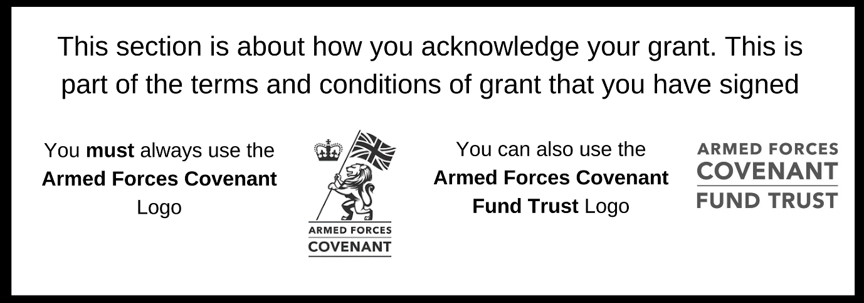

**When your project is underway**

Celebrate what you are achieving by letting people know about your activity

Local newspapers always like to hear about great things going on in their local community. Write a press release. This should ideally be 2-3 paragraphs long, and talk about why your project is exciting. Put some information about your organisation in a ‘notes to editors’ section below. Don’t forget to say that your project is funded by the Armed Forces Covenant Fund Trust

Your press release can also go wider- do consider sending to your local radio stations or even local TV news.

**When your project is completed**

It’s time to celebrate the achievements of your work.

* Think about what really worked well on your project- did it bring people together? Perhaps approach a few people involved in your project to see if they will give you some quotes that you could use in a press release or story on your website that you could promote through social media
* Did you develop or purchase something that will have a longer lasting impact? Get some photos and send out a press release

**Using the brand**

As part of your terms and conditions of grant, you have undertaken to use the Armed Forces Covenant Fund Trust branding. This lets people know that the funding for your project is funded from the Covenant Fund. It is important that you publicly acknowledge the funding that your project has received and we will ask you, as part of your grant monitoring, to show us how you have done this. If your 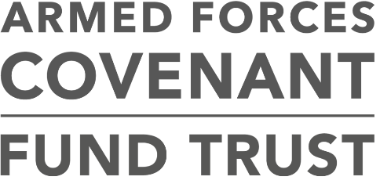project has difficulties in being able to use our brand, then it is important that you talk to us about this.

**Armed Forces Covenant Logo**

This guide will provide you with more information on how to use the brand, particularly in how to use the Armed Forces Covenant logo. This is the logo which contains the lion; and the words ‘Armed Forces Covenant; The ways in which you use the brand to acknowledge your grant should be proportional to the size of your award. If you are not sure if you have done enough, we are happy to give advice.

**Armed Forces Covenant Fund Trust Logo**

However you choose to acknowledge your grant, it must be for the life of your project. This will depend on the nature of your grant - if it funds services, it will be for the duration of the services we funded; if it is for a capital project, as long as that project exists in the form we funded.

**Where to use the logo**

Everybody who visits your project; takes part in your activities or uses your services that are being supported through your grant should be able to see that it was funded by the Armed Forces Covenant Fund Trust with funding from the Covenant Fund which supports the Armed Forces Covenant.

The following section gives more detailed information on ideas using the Armed Forces Covenant logo. However, this isn’t exhaustive and you may have ideas of your own, more suited to your project, and we’d love to see any innovative uses of our logo if you have them. The important thing is to let people know about your funding.

You can also use the logo for the Armed Forces Covenant Fund Trust. If you however only have room for one logo; you must use the Armed Forces Covenant Fund Logo; which we have shown you on the previous page.

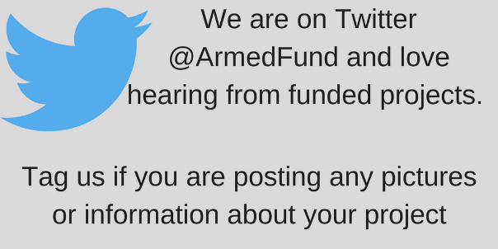

**Websites and social media**

If your project has a website, our logos should appear on the home page. Please ensure that they are large enough to be legible on screen. We would expect to see acknowledgement of your grant on your website.

**Using the logo on a building**

If we have funded capital or building works as part of your project then this must be publicly acknowledged. You can do this through signs, plaques or by having the logo on site boards and hoardings while your project is under construction. If you are using a plaque please make sure it is placed somewhere where it can easily be seen by visitors to your building. We understand that sometimes there may be a cost in doing this; and would be happy to talk with you about whether this can come out of your grant. In some circumstances we may be able to supply plaques. Our plaques will only contain the Armed Forces Covenant Fund Trust and Covenant Fund logos. If you wish to have your logo or other branding on the plaque then you would need to make your own arrangements.

**Using the logo on equipment**

If you purchase a vehicle with your grant, then you must display the Armed Forces Covenant logo where it can be easily read. If it is not possible to affix a sticker on equipment, you should acknowledge our contribution by other means, for example a mention on your website or a nearby plaque.

**Events**

Your grant must be acknowledged at any event you host. This can include launch or celebration events or conferences. We would also like you to tell us about any events that you are having in advance.

ed Forces Covenant Logo must be included when producing any form of promotional

**Publications and printed material**

The Arm or publicity materials, including posters, press releases, leaflets, brochures and annual reports. The Armed Forces Covenant Fund Trust Logo can also be used. You may decide to add our logo to your stationery by having it commercially printed or adding it to your templates. Our logo must be easily visible and conform to our minimum size requirements.

**Press releases**

All press releases about your work funded by the Covenant Fund should also include the Armed Forces Covenant Logo, and can also contain the Armed Forces Covenant Fund Trust Logo. Please send us copies of any press releases that your project sends out. You will also need to keep copies of these to include with your End of Project report, along with details of any other promotional activity that you have undertaken.

**Advertising**

You will need to include our logo if you are advertising your project, or recruiting for staff or services which we have funded. If the cost of advertising space will not allow you to include the logo in a size that is clearly legible, the following text can be used instead: ***Funded by the Armed Forces Covenant Fund Trust with funding from the Covenant Fund.***

**How to use the logo**

You should register to download the brand logos using this link: <http://defencebrandportal.mod.uk/bms/?link=19CE5405>

The logos for Armed Forces Covenant can be found within the ‘Schemes and Campaigns’ section. Do be aware that the Covenant Fund is part of the wider Armed Forces Covenant and that some of the resources that are available on this site may be less relevant to your work.

This is the logo illustrated here. When downloaded, the logo will open in a photo viewer. You may find it helpful to open it in another format such as a paint programme, which will enable you to cut and paste it into other documents.

There are a number of logos that are available for website and professional use. If you are working with a designer or other communications professional as part of your project, then you may like to direct them to the Defence Brand Portal, or to the brand guidance available at [www.armedforcescovenant.gov.uk](http://www.armedforcescovenant.gov.uk). You can also read the terms and conditions regarding use of the logo on this site.

You can download the Armed Forces Covenant Fund Trust Logo from [www.covenantfund.org.uk](http://www.covenantfund.org.uk) in the for grantholders’ section

There are a few important points to be aware of when using the logo.

* Please don’t change the colour of the logo. If you need a colour logo then an additional secondary colour palette containing three colours is available.
* Please make sure that when you use the logo that it is bigger than 20mm along the bottom of the logo on printed materials. This ensures that people can see it effectively.
* Please try to keep some space around the logo, so that it stands out. As a minimum, the space around the logo should be the size of the crown within the logo.
* Please make sure that the logo is not fuzzy or distorted when you are using it.

More detailed information is available in the Armed Forces Covenant Brand guidance, which is available from the Defence Brand Portal

If you have any queries, please contact us at [enquiries@covenantfund.org.uk](mailto:enquiries@covenantfund.org.uk)

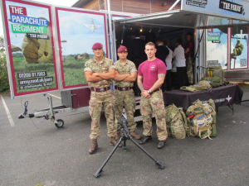**Photography and video**

Sending us pictures and videos of your work is a good way to show us about how your project has been delivering the activities that you applied to do.

We know that projects supported through the Covenant Fund have been delivering great support to veterans and serving personal, their families and wider communities. We want to be able to celebrate the work that your project is delivering, and inspire others to think about the Armed Forces Covenant.

**Gaining consent for photographs and video footage**

You need to get consent from people you would like to photograph or film, especially if you plan to use the images for publicity purposes – both in print and online. This includes your social media activity.

When you seek consent we recommend that you produce a form that you can get people to read and complete at your event. It is also a good idea to let them know an event will be filmed or photographed when they arrive. Suggested content for you consent form can be found in the sample document contained within this guidance.

**How your photographs and video footage may be used**

We may wish to use photographs and videos that you have produced in publications and wider promotional activity about the Covenant Fund. This may also raise awareness of your project among the general public. We can only do this if we are sure that the people featured in photographs or videos have consented to their image being used in this way. When you send us pictures or videos of your project please let us know if we can use these for wider publicity purposes. Please don’t send us copies of completed consent forms unless we specifically request them, but do please keep copies of completed consent forms with your grant records.

**Sample form**

**Film and photography consent form**

Thanks for coming to our project. We are recording our event and may use some of this material to promote our work. Our funders may also use pictures and videos from this event for promotional purposes. If you are happy to be included in this activity please complete the form below.

|  |  |
| --- | --- |
| Name |  |
| Address |  |
| Date of Birth |  |

1. You grant permission to the (insert your organisation’s name and address here) and to the Armed Forces Covenant Fund Trust to use and disclose your:

(a) image, physical likeness and name (images); and

(b) voice and sound (sounds), without restriction in any media or format.

You will let (insert your organisation’s name here) know if you wish to withdraw this permission.

2. Your permission includes the (insert your organisation’s name here) and the Armed Forces Covenant Fund Trust using your images or sounds for any publicity or advertising in connection with its work, and disclosing your images or sounds to other organisations (such as media and advertising agencies) for publicity purposes.

3. You have volunteered your images and sounds and agree that you will not receive or request any payment, royalty or other form of consideration for your images, sounds or participation in any project of the (your organisation’s name here).

Signature_____________________________ Date_______________

**If the individual is under 16 years of age their parent, legal guardian or authorised legal representative must sign below:**

4. I confirm that I am the parent, legal guardian or authorised legal representative of this individual and warrant that I have lawful authority to sign this consent form for and on their behalf.

5. I have read, and understand the terms and conditions and consent to the individual providing their Images and Sounds on these terms and conditions.

Signature_____________________________ Date_______________

***About us***

**The Covenant Fund was previously administered by an in-house MOD team and the funding has moved to the new independent trust as from 1 April 2018. The Armed Forces Covenant Fund Trust manages the grant programmes funded by the Covenant Fund. You can find out more about our work at** [**www.covenantfund.org.uk**](http://www.covenantfund.org.uk)**.**

**The Covenant Fund is an annual grant of £10 million which is paid to the Armed Forces Covenant Fund Trust to fund grant programmes that support the armed forces community.**

**The Covenant Fund makes grants in support of the Armed Forces Covenant. There are four overall themes that the Covenant Fund must take into account now and in future years when making decisions.**

* **Non-core healthcare services for veterans;**
* **Removing barriers to family life;**
* **Extra support after service for those that need help; and**
* **Measures to integrate military and civilian communities and allow the Armed Forces community to participate as citizens**

***About the Armed Forces Covenant***

**The Armed Forces Covenant is a promise from the nation that those who serve or have served, and their families, are treated fairly.**

**You can find out more at** [**https://www.armedforcescovenant.gov.uk/**](https://www.armedforcescovenant.gov.uk/)



**Contact details**

[**www.covenantfund.org.uk**](http://www.covenantfund.org.uk)

[**enquiries@covenantfund.org.uk**](mailto:enquiries@covenantfund.org.uk)